The counting Principle
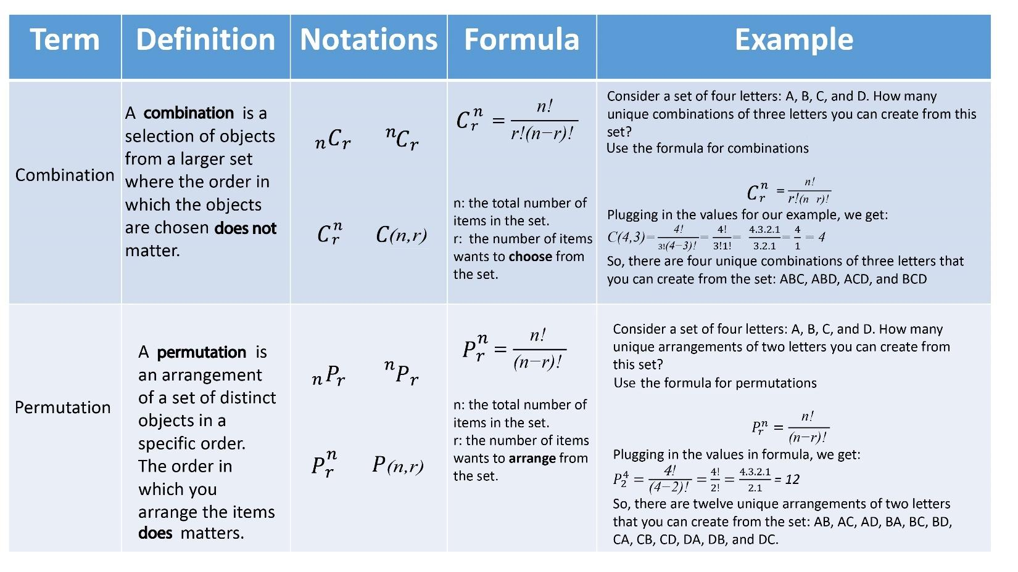
Here is a summary of Combinations and Permutations, you probably do not get too many questions about it on the test (GED ACT or SAT) but just in case I gave you the formula and examples of how to do it and interpret this kind of problem.

Remember to Calculate Combinations and Permutation you need to understand factorial and how to do operations with factorial. Here is another summary.

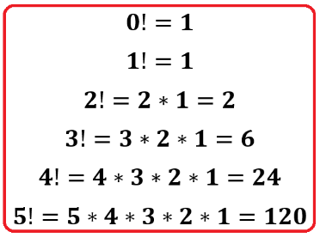

Factorial of a whole number “n” is defined of the product of all whole numbers less than or equal to “n” until 1.

