Quadratic and Square Root Equations

$x^{2}-120=1$ $\sqrt{x}=7$

${2x}^{2}-3=69$ $2\sqrt{x}+8=16$

$\frac{x}{50}=\frac{2}{x}$ $\frac{-2\sqrt{x+3}}{4}=-8$

${4x}^{2}-3=-12$ $-4\sqrt{x}-12=20$

I want to share some videos that you can find in YouTube where I preach about the ONLY True
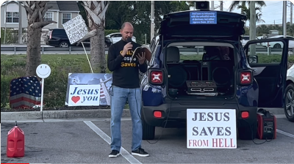
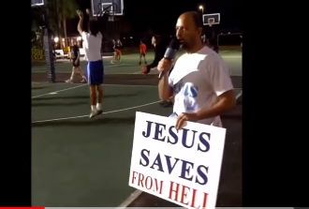

What is Faith / Preaching about Faith Playlist: Preaching Jesus Christ

