Linear Equations
1. Graph the following Equations:
$y=-x$ $y=\frac{1}{3}x-2$
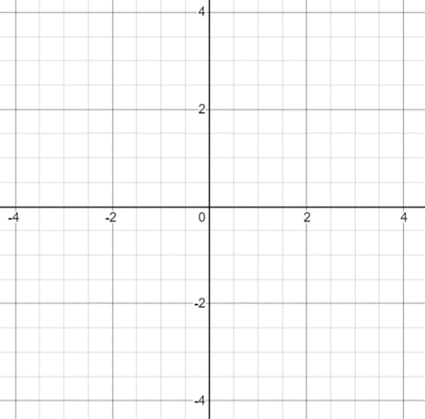

2. Write the equations given in the graphs.
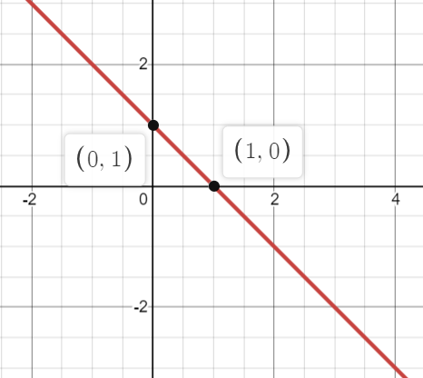
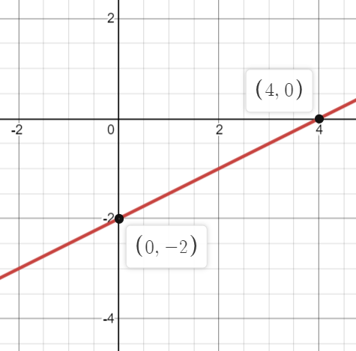
a) b)

3. Write an equation for each of the Table below.
