Line Graph

A line graph is a type of graph that uses a series of data points connected by lines to represent the data that is being analyzed. Line graphs are mostly used to show changes over the period such as changes in the stock market, growth in a company, changes in temperature over the course of time and many other situations.

Example
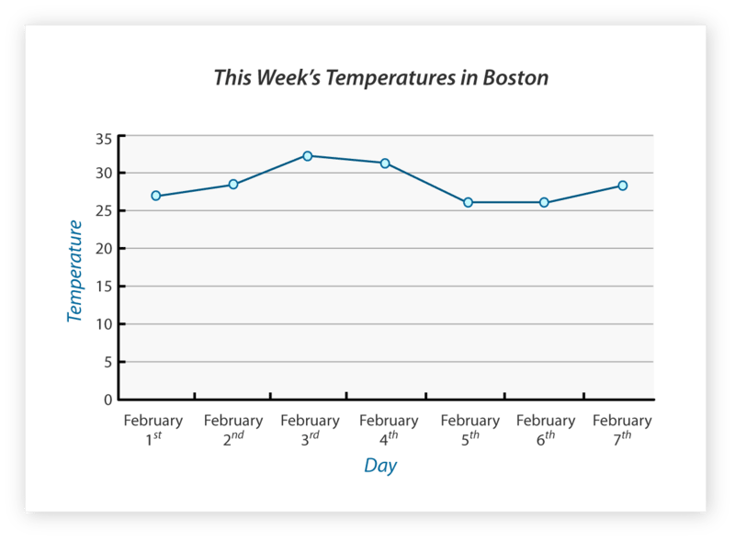

The above line graph shows the temperature changes over the course of a week. Each day is represented by a point on the graph, and the points are connected by a line. The y-axis represents temperature in degrees, and the x-axis represents time.

