Graph Analysis
Graph Analysis is the process of interpreting the data that has been represented visually in the form of graphs. Graphs are used to represent data in a way that is easy to understand and analyze in the fields of science, economics, and finance. Graph analysis involves interpreting the data that is presented in the graph, identifying patterns, trends, and relationships that may not be immediately apparent from the data itself.
There are many types of graphs, each of which has a different purpose and can be used to represent different types of data. Here are the most common three types of graphs.

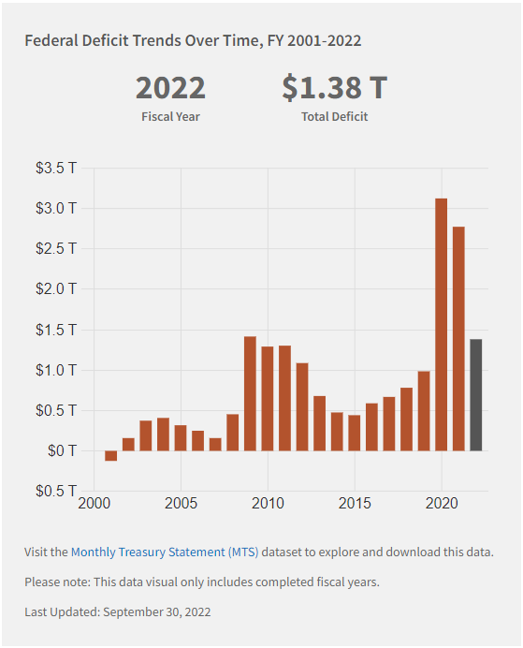
Bar Graph
A bar graph is a type of graph that uses rectangular bars to represent the data that is being analyzed. The height or length of each bar corresponds to the value of the data, and different colors can be used to represent different categories of data. Bar graphs are commonly used to show comparisons between different categories of data, such as the number of years in a range.

Example
Graph source https://fiscaldata.treasury.gov/americas-finance-guide/national-deficit/
The above bar graph shows Federal Deficit Trends Over Time. Each bar represents one year (x-axis), and the different colored bar represents the current year, the height of each bar (y-axis) corresponds to the amount of the deficit in Trillions of dollars.

