So God created man in His own image; in the image of God He created him; male and female He created them. Genesis 1:27

Find the perimeter and area of the following figure.
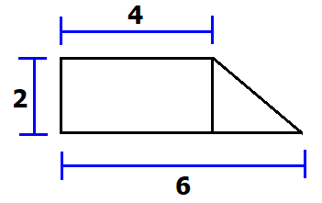

Perimeter: You need to add all the sides around the figure. Also, you need to use Pythagorean theorem to find the missing side (diagonal = $\sqrt{8}$) the final answer is
12 + $\sqrt{8}$ (Perimeter is given in linear unites like m, in, ft, km, yd, mi, etc.)

Area: Find the area of the triangle and the area of the rectangle and you add. Area of the rectangle is 4 * 2 = 8 and area of the triangle 2 * 2 / 2 = 2; Final Answer = 10
(Area is given in square units like m², in², ft², km², yd², mi², etc.)

In conclusion, Area and Perimeters are important concepts in geometry and are used in various fields such as architecture, engineering, construction, art, and many others.

