Find the Intercepts
Given: Graph, Table and Equation


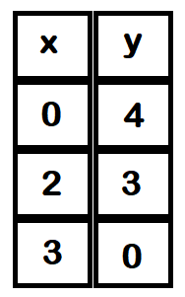



And he brought them out and said, “Sirs, what must I do to be saved?” So they said, “Believe on the Lord Jesus Christ, and you will be saved, you and your household.” Acts 16:30-31

