Circle Graph
A circle graph is also known as a pie chart, is a type of graph that uses a circle, divided into sectors, to represent the data that is being analyzed. The size of each sector corresponds to the proportion of the data that belongs to that category. Different colors can be used to represent different categories of data. Circle graphs are mostly used to show the proportion of different categories of data such as the proportion of different types of vehicles on a road.
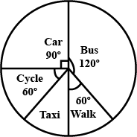

The above circle graph shows the proportion of different types of vehicles on a road. Each type of vehicle is represented by a sector of the circle, and the size of each sector corresponds to the proportion of vehicles on the road that belong to that category.
In conclusion, the type of graph used depends on the nature of the data that is being analyzed and the purpose of the analysis. By understanding how different types of graphs work, we can more easily interpret and analyze the data they represent.

Do you not know that the unrighteous will not inherit the kingdom of God? Do not be deceived. Neither fornicators, nor idolaters, nor adulterers, nor homosexuals, nor sodomites, nor thieves, nor covetous, nor drunkards, nor revilers, nor extortioners will inherit the kingdom of God. 1 Corinthians 6:9-10

