Application of Linear Functions in *Business.*

The function of the Cost has a higher y-intercept, and the function of the sells has a greater slope.

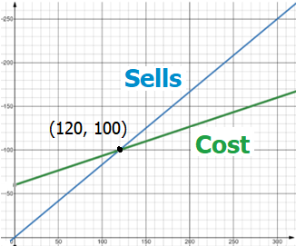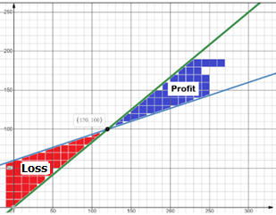

What can you conclude about profit and loss?

Find the equations of the line for Cost and Sells with the information provided in the graph.

Why in Business the function of Sells must have greater Slope than the function of Costs?

What is the meaning of the point (120, 100) in the context of the information?

And he brought them out and said, “Sirs, what must I do to be saved?” So they said, “**Believe on the Lord Jesus Christ**, and you will **be saved**, **you** and **your household**.” Acts 16:30-31